H.T No
Regulations:
A17


Sreenidhi Institute of Science and Technology
(An Autonomous Institution)
Code No: 6B517 Date: 03-Jan-2020 (FN)

B.Tech III-Year I-Semester External Examination, Dec-2019/Jan-2020 (Regular)
DESIGN OF MACHINE MEMBERS-I (ME)

Time: 3 Hours Max.Marks:75

Note: a) No additional answer sheets will be provided.
b) All sub-parts of a question must be answered at one place only, otherwise it will not be valued.
c) Missing data can be assumed suitably.

Part - A Max.Marks:25

Answer all QUESTIONS.

1. | What are the basic requirements of a machine element? | [3M]
2. | What are the different types of varying loads? | [3M]
3. | Differentiate between a cotter joint and a knuckle joint. | [3M]
4. | Define spring rate and spring index. | [3M]
5. | What are the different applications of screwed fasteners? | [3M]
6. | Define eccentrically loaded welded joints. | [2M]
7. | Define Notch sensitivity factor. | [2M]
8. | What is the difference between rigid and flexible coupling? | [2M]
9. | What are the different types of riveted Joints? | [2M]
10. | List out the various types of sunk keys. | [2M]
Part – B Max.Marks:50
ANSWER ANY FIVE QUESTIONS. EACH QUESTION CARRIES 10 MARKS.

11. |  | A bolt is subjected to an axial force of 10KN with a transverse shear force of 5 KN. The permissible tensile stress at elastic limit is 100 MPa for the bolt material. Determine the diameter of the bolt required according to  - Max. principal stress theory.  - Max. shear stress theory.  Iii) Max. Distortion energy theory. | [10M]
12. |  | A stepped shaft subjected to a twisting moment of 20 N-m. The yield strength of the shaft material is 400 Mpa Taking factor of safety of 2.5, r= 5mm,d=25mm,D= 50mm . Determine the diameter of the shaft.  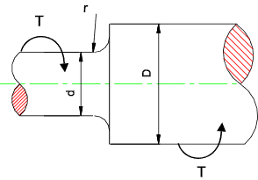 | [10M]
13. |  | Design a muff coupling to connect two shafts transmitting 40KW at 120rpm.The permissible shear and crushing stress for the shaft and key material (mild steel) are 30Mpa and 80Mpa respectively. The material of muff is cast Iron with permissible shear stress of 15Mpa. Assume that the maximum torque transmitted is 25 percent greater than mean torque. | [10M]
14. |  | A helical spring is to support a load of 1000N. The spring is guided by a rod of 50mm diameter. The spring undergoes a deflection of 40 mm under the load. Determine the diameter of the wire and the number of turns required, Use C-60 steel with a factor of safety 2. | [10M]
15. |  | A stream engine cylinder of 270 mm diameter is supplied with steam at 1.75 N/mm². The cylinder cover is fastened by means of 20 bolts of size M20. Joint is made leak proof by means of suitable gaskets. Find the stresses produced in the bolts. | [10M]
16. | a) | What are the advantages and disadvantages of welded joints over riveted joints? | [5M]
 | b) | A bracket carrying a load of 15 KN is to be welded as shown in Figure. Find the size of weld required if the allowable shear stress is not to exceed 80 MPa.  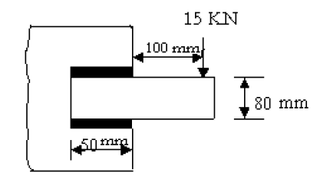 | [5M]
17. | a) | Explain the basic procedure for Mechanical Engineering Design. | [3M]
 | b) | Discuss the Stress concentration in manufacturing design. What are the different methods to reduce the stress concentration factor? | [4M]
 | c) | Sketch any two sunk key diagrams and explain the design procedure. | [3M]
18. | a) | Discuss the materials and practical applications for the various types of springs. | [4M]
 | b) | What is the difference between caulking and fullering? Explain with the help of neat sketches. | [3M]
 | c) | What are the types of Welded Joints? | [3M]

-- 00 -- 00 –

